Predictive Modeling of Flood Hazards Assessing the Impact of Deforestation and CO2 Emissions in Pakistan
____________________________________


by
M Hasnain Abbas Khan
2023-MS-DS-15
Research Supervisor:
Dr. Junaid Arshad
2025
_______________________________________
Institute of Data Science
University of Engineering and Technology, Lahore
PREDICTIVE MODELING OF FLOOD HAZARDS ASSESSING THE IMPACT OF DEFORESTATION AND CO2 EMISSIONS IN PAKISTAN

by
M Hasnain Abbas Khan

A THESIS
presented to the university of engineering and technology, Lahore
in partial fulfillment of the requirements for the degree of
Master of Science
in
Data Science
APPROVED BY:

[Primary Advisor/Internal Examiner] [External Examiner]
[Official Title & Department] [Official Title & Department]

[Chairman of the Department] [Dean of Faculty]

[Publish Date]

INSTITUTE OF DATA SCIENCE
UNIVERSITY OF ENGINEERING & TECHNOLOGY, LAHORE

© 2025
M Hasnain Abbas Khan
All Rights Reserved
Any part of this thesis cannot be copied, reproduced or published without the written approval of the Scholar.

ABSTRACT
Flood risk in Punjab, Pakistan has significantly increased past few years by changing climate pattern and human-induced environmental degradation. In classical hydrological analyses, these factors are generally treated individually, which leads to an incomplete flood risk assessment. In this paper, we employ an interpretable machine learning (ML) framework to analyze district-level flood probabilities and their important drivers. The study is based on a large multidisciplinary dataset of 5500 observations from 14 districts of Punjab (2010–2022) and includes a total of 13 climatic, hydrological, topographic and anthropogenic covariates. Three ML models Random Forest, XGBoost and CatBoost were trained and tested with CatBoost proving to be the best one (R² = 0.997). For transparency, a combined XAI approach comprised of SHAP values, Permutation Importance as well as Partial Dependence Plots (PDPs) was used. Findings indicate that Rainfall Intensity is the largest predictor (28.7) at a critical level of about 400 mm, Deforestation (17.6) and CO2 emissions (14.2) together form 31.8% of the hazard prediction that is almost equivalent to climatic factors. These results oppose hydrology-centered views by demonstrating how the risk of flood is produced by the interchangeable human-environment mechanisms. The spatial patterns show Southern Punjab and Muzaffargarh, in particular, to be the most susceptible area because of the exposure to climatic conditions and poor land-use management. In general, this paper offers a clear XAI-based model of quasi-experimental modelling, presents the first quantitative iteration of deforestation on the dynamics of floods in Pakistan, determining both practical actionable thresholds in terms of early warning, and policy recommendation on targeted and sustainable mitigation of floods.

ACKNOWLEDGMENTS
I want to thank my supervisor Associate Prof. Dr. M Junaid Arshad for the excellent supervision and guidance. I want to thank the Institute of Data Science at UET Lahore including professors, seniors, and batch mates for supporting this research.

STATEMENT OF ORGINALITY
It is stated that the research work presented in this dissertation consists of my own ideas and research work. The contributions and ideas from others have been duly acknowledged and cited in the dissertation. This complete dissertation is written by me. If at any time in the future, it is found that the thesis work is not my original work, the University has the right to cancel my degree.

M Hasnain Abbas Khan

LIST OF FIGURES
LIST OF TABLES

NOMENCLATURE
Symbol | Description
ML | Machine Learning
SMOTE | Synthetic Minority Over-sampling Technique
SHAP | SHapley Additive exPlanations
PDP | Partial Dependence Plot
CatBoost | Categorical Boosting
XGBoost | Extreme Gradient Boosting
MAE | Mean Absolute Error
RMSE | Root Mean Square Error
R² | R-Squared (Coefficient of Determination)
IID | Independent and Identically Distributed
CO₂ | Carbon Dioxide
mm | Millimeter
km | Kilometer
m | Meter
cusses | Cubic Feet per Second (ft³/s)
KT | Kilotons
°C | Degrees Celsius
ha | Hectares

1. INTRODUCTION

1.1. BACKGROUND

Floods are one of the most devastating and frequent natural hazards in the world, which caused a significant displacement of humans, destruction of agriculture, damage to infrastructure, and caused a broad socioeconomic interference (IPCC, 2021). A country such as Pakistan located in the climatically unstable monsoon region has become one of the most flood prone countries in the world. The rapid increase in the number and severity of flood incidents over the last twenty years in addition to the one brought about by extreme precipitation phenomenon, have been fueled not only by the tremendous land-use change but also by intensive deforestation, progressive soil erosion, and climatic intensification through the influence of CO2 (Ali et al., 2023).
The agricultural hinterland of Pakistan, Punjab Province has been grossly affected because of its severe hydrological location in the Indus Basin System. The province has a diverse geographical set up characterized by its having been located at the junction of popular tributaries of the Indus River, as well as, having a large population (more than 110 million) and extensive agricultural practices which make it highly vulnerable to disasters associated with floods. Punjab has witnessed seven major floods during the period, 2010-2022 which have impacted millions of people and cost billions of dollars in damages to their economies.

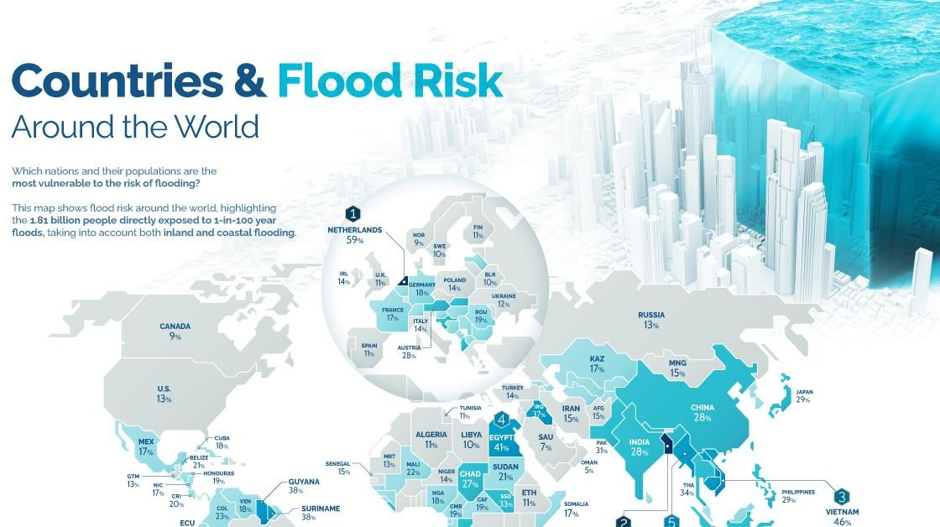
Figure 1.1: Global flood risk distribution highlighting Pakistan's exceptionally high vulnerability relative to other developing regions
One of the most important factors that contribute to the increased susceptibility of Pakistan is the increased rate of degradation of the ecology. The share of forest in Punjab has become a consistent downward trend in the last 20 years as it declined to around 2.5 percent by 2024, which reduced the capacity of infiltration significantly, thereby raising the surface runoff in the light-to-moderate rainfall conditions (Khan & Rahman, 2022). This active deforestation has radically changed both the hydrological reaction of watersheds and increased the risk of floods beyond that caused by climate changes in precipitation only.

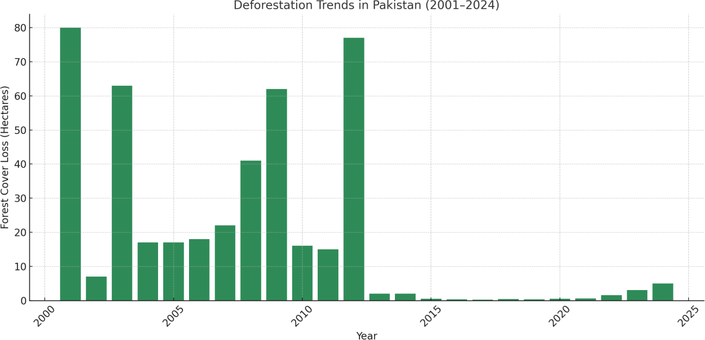
Figure 1.2: Forest cover decline in Punjab Province (2001–2024) showing progressive loss of watershed buffering capacity
These land-surface changes have worked in a synergistic manner in response to anomalously strong events of monsoons, the most extreme example of which was the 2022 mega-flood. In the context of it being a disastrous and tragic event, the intensity of the rainfall was 7-fold more than the long-term climatological baseline in some districts, and some regions received their annual rainfall in one or two weeks (PMD, 2022). Flood impacted more than 33 million population in the country with a big proportion of this being felt by Punjab. This occurrence highlighted the complex character of the flood risk in the area where climatic extremes and environmental degradation meet to increase the magnitudes of disasters.
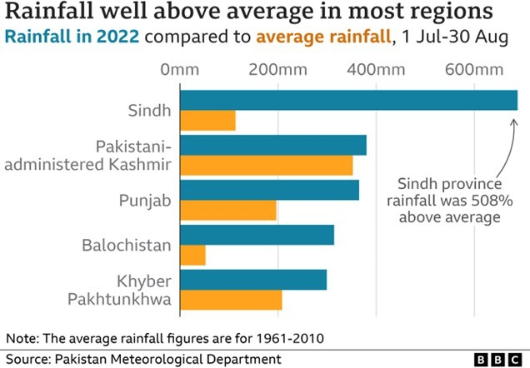
Figure 1.3: Spatial rainfall anomaly during the 2022 Pakistan floods, concentrated over Punjab and Sindh provinces
The changing risk dynamics notwithstanding, conventional flood risk assessment systems in Pakistan still operate almost solely on hydrological and meteorological indicators of risk, chiefly rainfall intensity and river discharge. This system of hydrology-based thought is a systematic underestimation of the processes of land degradation and the inability to define the non-linear interaction between climate and ecological system. As a result, spatial flood risk has not been sufficiently defined and the warning systems developed are reactive not proactive. The lack of both natural and anthropogenic driver coverage model is one of the serious deficiencies in the disaster preparedness infrastructure in Pakistan.

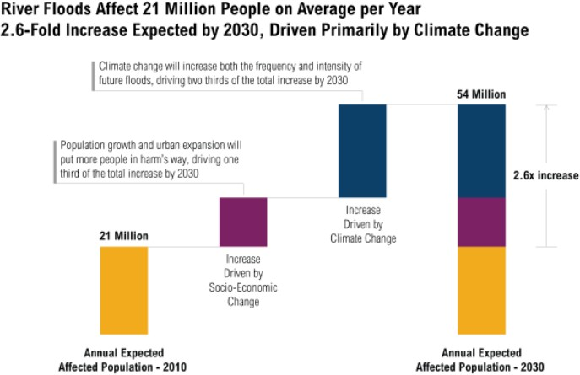

Figure 1.4: Projected growth in flood-affected population (2010–2030) under coupled climate land degradation scenarios

PROBLEM STATEMENT
A thorough analysis of the available literature states that there are numerous limitations of the current methodology of flood risk assessment in Pakistan. Such gaps as summarized in Table 1.1 have led to poor characterization of risk and poor preparedness strategies to deal with disasters specifically in the sub-provincial level where the policies are to be implemented.
Table 1.1: Limitations in Existing Flood Risk Studies and Their Implications
Limitation in Existing Studies | Resulting Problem
Rainfall and discharge utilized as sole predictors | Systematic neglect of deforestation and CO₂ emission impacts on flood risk
Application of static or linear statistical models | Inability to capture nonlinear climate–land–hydrology interactions
Absence of explainable AI frameworks | Limited transparency in decision-making; "black-box" models reduce stakeholder trust
Provincial-level aggregation only | Masking of critical district-level spatial heterogeneity in flood vulnerability
Insufficient model validation with interpretability metrics | Reduced confidence in findings and limited policy uptake

1.2.1 Neglect of Anthropogenic Drivers
Although universalists argue that rainfall and river discharge are the primary drivers of floods, the role of land-use change particularly deforestation and urbanization, often represented through CO₂ emissions remains poorly quantified and insufficiently integrated into Pakistan’s flood-risk models. This results in systematic underestimation of risk and the neglect of critical, and largely mitigable, contributing factors.
1.2.2 Limitations in Model Interpretability
The use of machine learning in flood prediction is increasing at a rapid pace, but most researchers utilize advanced black-box models that do not provide insights into the forces behind the risk. This obscurity constrains their applicability to policymakers and disaster management officials who need clear, operational knowledge in order to do badly needed planning and intervention.

1.2.3 Inadequate Spatial Resolution
When flood risk is assessed only at the national or provincial level, important district-level variations in vulnerability, exposure, and contributing factors become obscured by aggregation. This coarse-scale evaluation prevents the identification of the most threatened locations and limits the ability to allocate resources or design interventions effectively, ultimately reducing the impact of disaster mitigation efforts.
1.2.4 Synthesis of Research Gaps
The combined effect of these methodological gaps is that a comprehensive and reliable understanding of flood dynamics in Punjab remains unattainable. This underscores the urgent need for an interpretable, multi-factor machine learning model operating at high spatial resolution to quantitatively and explicitly measure, compare, and rank the contributions of both climatic and anthropogenic drivers.

RESEARCH GOAL
1.3.1 Primary Research Aim
The study will focus on the development of the strong, interpretable machine learning model to simulate the probability of flooding and establish the anthropogenic and climatic factors as the most significant drivers of flood risk scenario in Punjab, Pakistan, during 2010-2022.

1.3.2 Specific Objectives
      - Data Integration: To create an overarching comprehensive, district-level dataset combining 13 functions in the fields of climatic (rainfall, temperature), hydrological (river discharge, reservoir levels, distance to river), and anthropogenic (CO2 emissions, deforestation rate, land cover type) domains in the years 2010-2022.
      - Model Development and Comparison: In order to apply and comparatively test several sophisticated tree-based machine learning models namely: Random Forest, XGBoost, and CatBoost to predict with general reliability the occurrence of floods, in a district level.
      - Explainable AI Application: To apply explainable AI (XAI) methods, including Permutation Importance, SHAP (SHapley Additive exPlanations) and Partial Dependence Plots (PDPs) to identify, rank, and interpret the most important factors leading to flood risk using transparency.
      - High-Risk Zone Identification: To confirm the model performance, detect spatial distributions of vulnerability, and identify the high-risk districts that would offer the solution to specific policy intervention and the flood-reduction planning.
1.3.3 Rationale for Punjab Province Selection
Punjab Province was selected as the study area based on the following strategic considerations:
- Agricultural Significance: Punjab is the source of about 60 per cent of total agricultural produce of Pakistan and therefore, derived national economic significance because of flood effects.
- Rapid Land-Use Change: The fastest rates of deforestation and urban growth in Pakistan are in the province, which provides a perfect setting to study the impacts of an anthropogenic factor on the risk of flooding.
- Hydrological Centrality: Punjab lies at the center of flood-receiving land of the Indus Basin and it is crossed by five major tributaries, which makes it hydrologically representative of the riverine flood processes.
- Spatial Heterogeneity: District level topography, land use, and flood exposure constitute a significant source of variation on the spatial scale, which would be an ideal test case of spatially disaggregated risk modeling.
- Data Availability: There are comparatively rich national and international data sources, which allow compiling a powerful, multi-source panel dataset.

SCOPE OF THE STUDY
The study is limited to the formulation and testing of an interpretable machine learning model to predict the risk of flood on Punjab Province of Pakistan, between the years 2010 and 2022. The analysis is based on 14 Punjab districts and grounded on refined data on 5,500 district years of 13 predictor variables. The approach to methodology also includes the use and comparison of three tree-based ensemble algorithms (Random Forest, XGBoost, CatBoost) and the application of particular Explainable AI (XAI) systems, SHAP, Permutation Importance, and Partial Dependence Plots, to interpret the model. The research is corroborated with past flood data and gives a basis, high-resolution risk evaluation that should be used in policy.

SIGNIFICANCE OF THE STUDY
The study has some meaningful contributions at various levels since it improves the methodology and implementation of flood risk assessment in Pakistan. The importance of the work is outlined below in the academic, practical, and social spheres.
1.5.1 Academic Contribution
The research offers a new, unified analysis model that simultaneously measures the effect of climatic and anthropogenic issues on the risk of floods. It provides a methodological improvement, in that it shows another comparative, interpretable machine learning pipeline that goes beyond native or black-box predictions to provide transparent, and causally interpretable information, shaping a paradigm shift of the type of understanding of flood causation in the area.
1.5.2 Practical and Policy Contribution
The researchers generate the initial district-scale, probabilistic flood hazard model of Punjab, which allows one to identify the high-risk areas with great precision in order to develop specific interventions used in these regions. Its results offer a natural science-policy interface, which provides scalable, empirical results that justify the reduction of disaster risks, adaptation to climatic changes, and the realization of long-term land-use planning.
1.5.3 Social Contribution
This research has the potential to increase early warning and disaster preparedness by improving accuracy and spatial resolution of flood risk assessment, which will eventually lead to a decrease in economic losses and prevention of the risk of vulnerable communities. The fact that the model is explainable instills confidence and enhances interaction between the scientists, policy-makers and the general population.

2. LITERATURE REVIEW

2.1 Introduction
The chapter critically overviews the current literature on flood risk assessment, the development of traditional (hydrological) frameworks to contemporary applications of machine learning (ML), and finally, the importance of explainable and integrated framework is justified. The review is organized to identify the local context and methodological development in Pakistan, review the progress in the whole world, and the need of Explainable AI (XAI) and analyze the importance of particular roles of climatic and anthropogenic drivers. The chapter ends with the research gap synthesis and the introduction of the synthesized conceptual framework on which this research is going to be guided. Table 2.1 has given a summary of major studies to place this critical analysis in a broader context.
Table 2.1: Summary of Selected Reference Papers
Sr. No. | Year | Author & Reference | Method | Technology/Data Used | Key Contribution | Limitations & Research Gaps
1 | 2025 | Ahmad et al. [13] | Ensemble ML + Hydrodynamic Modeling | HEC-RAS, Remote Sensing, ML | Hybrid physics-ML flood susceptibility mapping. | High computational cost; no XAI implementation.
2 | 2025 | Sajjad et al. [14] | Satellite-Index Mapping | MNDWI, NDVI, Google Earth Engine (GEE) | Rapid post-event flood assessment and damage mapping. | Reactive analysis; no predictive or causal modeling.
3 | 2024 | Ali et al. [6] | Statistical + Machine Learning | GIS, ML Datasets | District-level flood risk modeling in Pakistan. | No SHAP/LIME interpretability; "black-box" approach.
4 | 2024 | Khan et al. [8] | ML-based Prediction | Climate & Streamflow Data | Hydrology-based ML baseline for the Indus Basin. | No land-use variables; no XAI for driver analysis.
5 | 2024 | Singh & Raghavan [1] | ML Vulnerability Assessment | Environmental/Climate Data | Feature ranking for flood vulnerability. | Limited to basic importance metrics; no SHAP.
6 | 2024 | Gupta et al. [20] | Physics-Informed AI | GeoPINS Framework | Fusion of hydrological physics with AI. | Experimental; untested in data-scarce regions like Pakistan.
7 | 2024 | Hafeez et al. [18] | ANN + GIS | Remote Sensing, GIS | Spatial flood hazard classification. | Poor generalizability; opaque predictions.
8 | 2024 | Muhammad et al. [5] | Environmental Assessment | Emissions + Land-Use Data | Links deforestation & CO₂ emissions to flood risk. | Descriptive; no predictive integration into an ML model.
9 | 2024 | Mukhtar et al. [15] | GIS-MCDM | GIS, AHP | Multi-criteria vulnerability mapping in Hunza-Nagar. | Static expert weights; no adaptive learning from data.
10 | 2024 | Bazai et al. [10] | Geological Hazard Study | Historical + Geology Data | Emphasizes topographic contribution to flooding. | Explicitly calls for ML integration to improve analysis.
11 | 2023 | Rehman et al. [21] | Statistical Analysis | Land Use + Rainfall Data | Establishes rainfall-land degradation link. | No hydrological integration or quantitative driver ranking.
12 | 2023 | Nanditha et al. [23] | Post-Event Analysis | Historical Flood Records | Model calibration for the 2022 Pakistan floods. | Descriptive and retrospective only; not predictive.
13 | 2023 | Govt. of Pakistan [25] | Policy Assessment | National Policy Review | Documents climate risk governance gaps. | No model-based causal attribution for policy guidance.
14 | 2022 | Narisma & Wang [28] | Global Deforestation Study | Multi-Region Comparative Data | Quantifies deforestation-discharge relationship. | Not Pakistan-specific; lacks local validation.
15 | 2022 | Ahmad et al. [26] | Carbon Emissions Modeling | Environmental Modeling | Proposes CO₂ as a potential flood risk driver. | Limited spatial resolution; no ML integration.
16 | 2022 | Manzoor et al. [27] | Literature Review | Secondary Synthesis | Identifies analytical gaps in Pakistani flood research. | No novel modeling methods proposed.
17 | 2024 | Nishat et al. [2] | Statistical Modeling | Meteorological Data | Investigates deforestation's impact on local weather. | Regional specificity limits generalizability.
18 | 2024 | Tufail et al. [5] | Regression Analysis | Environmental, Socio-economic Data | Links poverty & governance to deforestation/emissions. | Lacks longitudinal data on climate change impacts.

2.2 The Evolution of Flood Risk Assessment: From Hydrological Models to Machine Learning
Flood risk assessment methodology has changed radically to abandon physics-based hydrological models and adopt data-driven techniques based on machine learning. The development is an indication that there is an increasing demand to work with complex, multi-dimensional data, and non-linear relationships that may not be easy to model using conventional models.
2.2.1 Traditional Hydrological and Statistical Approaches
The initial research in flood risk was based on hydrological models (e.g., HEC-RAS, SWAT) and geospatial Multi-Criteria Decision Making (MCDM). Such methods as by Mukhtar et al. offered much background information on the flood zones based on the static parameters, such as the elevation, slope, and river proximity. They were, however, constrained by their dependence on expert assigned weights, their failure to learn using data and their inability to capture non-linear interactions between changing risk factors. They said that where is subject to weakness and not the question why or how much would the risk differ with driver variability.
2.2.2 The Machine Learning Revolution
The adoption of machine learning marked a turning point, enabling models to learn complex patterns directly from data. In Pakistan, Ali et al. and Khan et al. were able to show that predictive accuracy of algorithms such as Random Forest and ANN is better than the traditional ones. This change made ML an effective instrument of flood prediction. Nonetheless, this initial generation of ML uses largely viewed models as black boxes with these applications focused on achieving high prediction accuracy rather than model understanding. This resulted in a performance-transparency trade- off in which the stakeholders were to believe in the output of a model without seeing the reasoning behind the model.

2.3 The Explainable AI (XAI) Imperative in Flood Modeling
The current frontier in flood risk assessment is the integration of Explainable AI to bridge the gap between high-accuracy predictions and actionable, trustworthy insights.
2.3.1 Global Advances in Model Interpretability
Techniques like SHAP (SHapley Additive exPlanations) and LIME have transformed gold standards to interpretation of complex models internationally. SHAP is based on the cooperative game theory that offers a mathematically valid methodology used to measure the input of each feature to a model prediction on a case-by-case basis. This is because it can be globally interpretable (what factors are the most important in general) and locally interpretable (the reason as to why a certain district has been classified to be of high-risk). Such studies as the one by Singh and Raghavan started employing feature importance scores but failed to take advantage of SHAP with its granular, consistent, and reliable attributions.
2.3.2 The Critical Gap in the Pakistani Context
The review on literature on Pakistani-specific floods clearly shows a sharp lack of sophisticated XAI applications. Although the accuracy of models is high, the causes behind the models are undisclosed. As an example, the refined hybrid structure introduced by Ahmad et al. and the ANN models developed by Hafeez et al. provide no clear process by which one can determine whether the model is using drivers that are realistic in the real world or the way the model justifies itself to policymakers. This unintelligibility is one of the primary obstacles to operationally using ML models in disaster management where causality as much as forecasting the impact is of interest.

2.4 Quantifying Key Flood Drivers: Beyond Rainfall and River Discharge
To have a strong appreciation of the risks of floods, it would be important to go beyond the hydrological aspects and incorporate anthropogenic contributors that essentially modify watershed response.

2.4.1 The Established Role of Climatic-Hydrological Factors
The ultimate and immediate antecedent to a flood occurrence is rainfall and river discharge which is where a predictive model should focus. The study by Khan et al. is eloquent in establishing the predictive ability of these hydro-climatic variables.
2.4.2 Anthropogenic Drivers: Deforestation and CO₂ Emissions
There has been an increasing number of evidence not only in the world but also in Pakistan that points to the increasing contribution of human activity.
- Deforestation: Research by Muhammad et al. and Rehman et al. in Pakistan, and global research by Narisma and Wang, indicates a positive relationship between a loss in the forest cover and a higher risk of flooding. It is a well-known mechanism, less infiltration and more surface runoff. Nevertheless, these studies do not measure the marginal or contributory component of deforestation to climatic drivers or contributors, in a single predictive model.
- CO₂ Emissions as a Proxy: According to the research of Ahmad et al., CO2 emissions may be used as a proxy of all landscape change, such as urbanization and industrialization, which enhance impervious areas and surface runoff. Nevertheless, this is yet a relatively under researched variable in Pakistan and therefore is not a well-analyzed direct input to ML-based flood models.
2.4.3 The Integration Deficit The critical gap is not a lack of awareness of these drivers, but a failure to integrate and rank them quantitatively. No existing research in Pakistan has been in a position to include the rainfall, river discharge, deforestation and CO2 emissions together as one model and applied XAI to subtract and compare their individual and interactive representations on the probability of floods.

2.5 Synthesis of Research Gaps and Conceptual Framework
This review outlines a three-fold interdepending gap that this thesis is directly aimed at.
2.5.1 The Interpretability Gap
The prevalence of black-box type ML models in the Pakistani flood literature restricts the use of such models to formulate policies. It is urgently required to incorporate the best XAI methodologies, such as SHAP, to deliver causal and clear explanations of the prediction of models.
2.5.2 The Driver Integration Gap
Existing models do not estimate contributions of the anthropogenic drivers (deforestation, CO2) in comparison to conventional climatic-hydrological factors. This is because the non-linear interactions among these drivers are not quantified.
2.5.3 The Policy-Translation Gap
The outputs of model do not provide a linkage between actionable insights of decision-makers and model outputs. Policymakers should not only understand what districts are at stake, but they must understand specifically what lever to pull (e.g. reforestation vs. reservoir management) and what the desired effect would be.
2.5.4 Integrated Conceptual Framework for this Study
In order to fill these gaps, the research is informed by a three-layered conceptual framework:
            - Data Integration Layer: Assembles complete data of 13 climatic, hydrological, and anthropogenic drivers of districts in Punjab (2010-2022).
            - Interpretable Modeling Layer: Uses a comparative ML framework (Random Forest, XGBoost, CatBoost) that has strong validation. The essence of such layer lies in the use of SHAP analysis and Partial Dependence Plots (PDPs) to break down predictions, prioritize drivers, and model counterfactual conditions, all in transparency of the entire model.
            - Policy Inference Layer: Maps model interpretations into operational intelligence, finds high-risk districts, prioritizes interventions by the contribution of the driver, and presents evidence to allocate resources accordingly.
This framework constitutes a paradigm shift in simply forecasting the threat of floods to diagnosing and making it accountable with the aim of offering a science-based, transparent and practical foundation of the flood mitigation policy in Punjab.

METHODOLOGY

3.1 Introduction
This chapter offers an extensive description of the methodological framework that was developed to meet the objectives of the research stated in Chapter 1. The main objective is to have a strong interpretable machine learning model to measure the possibility of flood and determine the major climatic and anthropogenic factors throughout Punjab, Pakistan. The research uses a six-phase analysis pipeline in order to guarantee transparency, reproducibility and scientific rigor. They include: (1) Study Area Characterization, (2) Data Acquisition and Curation, (3) Exploratory Data Analysis and Preprocessing, (4) Comparative Machine Learning Model Development, (5) Implementation of an Explainable AI (XAI) Framework and (6) Model Validation and Evaluation. The presented integrated approach is aimed precisely to bridge the gap between raw and multi-source data to open, policy-appropriate insights, and thus to close the gaps in the traditional assessment of flood risks that have been revealed in the literature review.

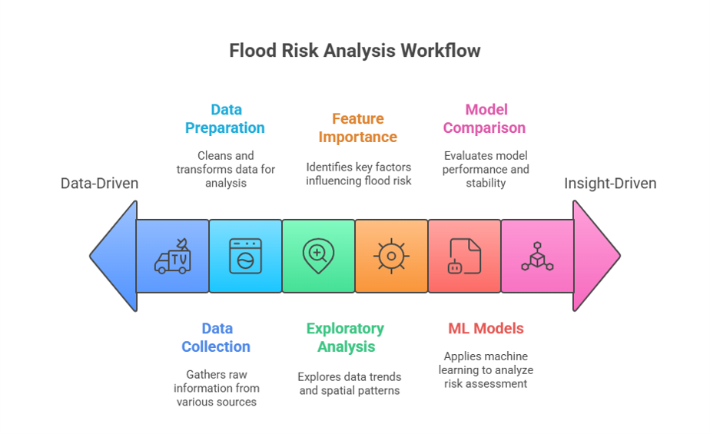
Fig. 3.1. Integrated analytical workflow for flood risk assessment, illustrating the sequential flow from data sourcing through to model interpretation and validation.

3.2 Study Area Characterization
The Province of Punjab (approximately 29°30′N to 34°02′N, 69°50′E to 75°23′E) was chosen because of its high level of vulnerability to floods, socio-economic factors, and the diversified environment. Being the agricultural backbone of Pakistan that provides more than 60 percent of national agricultural production, its safeguard is main source of food and economic security of the country.
3.2.1 Physiographic and Hydrological Context
The province lies within the strategic Indus River Basin which is crosscut by a system of large rivers such as the Indus, Jhelum, Chenab, Ravi and Sutlej rivers. Although this riverine system is essential to irrigation in terms of one of the largest canal systems in the world, it forms the major source of riverine flood hazard. Topographically, Punjab changes to the high, dissected land of the Potohar Plateau and the north foothills to a large, flat alluvial landmass of the central part and the south. The topographic gradient resembles an experimental setting on the elevation-mediated susceptibility to floods.
3.2.2 Climatic and Anthropogenic Context
The climate of the region has a sharp gradient with the south being arid (annual rainfall about 250 mm) and north being humid (annual rainfall of over 1000 mm) where the monsoonal regime dominates (June-September). This seasonality has been the focal point of precipitation which combined with the melting of the snows in the upper Himalayas are the main drivers of disastrous flooding as witnessed in the historic floods of the years 2010, 2014, and 2022. The anthropogenic pressure is an inherent aspect. The landscape has been changing dramatically with a population of more than 110 million with the fast urban and industrial growth. Such processes as deforestation to develop agricultural areas and fuelwood, and massive urbanization, substituting permeable systems with impermeable ones (concrete, asphalt), are key. These land-use adjustments directly modify the hydrological performance of watersheds by decreasing infiltration and increasing the pace of surface flow and putting flood risk into exaggeration by fairly low rainfall rates.
3.2.3 Spatial and Temporal Scope
The analysis will include all 14 districts of Punjab in the period 14 years (2010-2022). The timing of this temporal window was selected intelligently to include in it a full hydrological cycle consisting of several major floods and interludes of normal and low-level rainfall, such that the model learns strong associations and not only the signature of extreme events.

3.3 Data Acquisition and Curation
A multi-source and multi-disciplinary dataset were carefully compiled in order to consider the multifactorial character of flood hazard. They combined 13 predictor variables and the target variable based on both national and international data and an organized panel dataset of 5,500 district-years was obtained.
3.3.1 Data Sources and Feature Rationale
This choice of features was based on the conceptual framework of the formation of floods, which combines climatic triggers, hydrological response, topographic controls, and modifiers anthropogenic.
- Target Variable: Flood_Probability is a continuous index (0-1), based on Punjab Disaster Management Authority (PDMA) records of impacts, which is the probability of an event of a significant flood in a district per annum. The value of 0 means that the likelihood of the hazard is zero and a value of 0.5 represents the 50 percent chance, whereas 1 means a near-certain event. Such a continuous goal is better than a binary classification of regression models because it maintains the strength of the hazard.
- Predictor Variables: These are organized under four conceptual groups and this is as outlined under Table 3.1.
Table 3.1: Description of Predictor Variables and Data Sources
Category | Feature | Data Type | Description | Source | Rationale
Climatic | Rainfall_mm | Numeric | Total annual precipitation | Pakistan Meteorological Dept. (PMD) | Primary trigger of flood events.
 | Temperature_C | Numeric | Mean annual temperature | PMD | Influences evapotranspiration and snowmelt.
Hydrological | River_Discharge_cusecs | Numeric | Annual peak discharge | Water and Power Development Authority (WAPDA) | Direct measure of riverine flood potential.
 | Reservoir_Level_m | Numeric | Mean annual level | WAPDA | Indicates capacity to absorb excess runoff.
 | Distance_to_River_km | Numeric | Euclidean distance to nearest major river | Derived from SRTM DEM | Determines exposure to river overflow.
Anthropogenic | Deforestation_Hectares | Numeric | Annual forest cover loss | Global Forest Watch | Reduces infiltration, increases runoff.
 | CO2_Emissions_KT | Numeric | Annual CO₂ emissions | World Bank/FAOSTAT | Proxy for urbanization & industrial activity.
Topographic & Land Use | Elevation_m | Numeric | Mean district elevation | SRTM DEM (90m) | Controls drainage and flow accumulation.
 | Region | Categorical | Administrative district | Administrative Boundaries | Captures unobserved spatial heterogeneity.
 | Soil_Type | Categorical | Dominant soil class | National Soil Survey | Determines inherent infiltration capacity.
 | Land_Cover_Type | Categorical | Primary land use class | Remote Sensing (LULC) | Determines surface runoff coefficients.

3.3.2 Data Integration and Preprocessing
Multi-stage preprocessing pipeline was made rigorous in order to provide spatial and temporal consistency and to provide data integrity.
      - Spatial Harmonization: Each raster data (i.e., SRTM DEM, land cover maps) has been obtained at different sources and had varying resolution and coordinate systems. The standardized procedure was used:
  - Reprojection: The layers were reprojected in the same coordinate system (WGS 84 UTM Zone 42N).

  - Resampling: In continuous rasters, bilinear interpolation was used to resample continuous rasters to a standard 1 km² resolution, whereas categorical raster resampling was done with the nearest-neighbor algorithm to ensure the integrity of classes.

  - Zonal Aggregation: Zonal statistics were used to aggregate the harmonized rasters into district administrative boundaries as follows: the mean of continuous variables and mode of categorical variables were computed.

      - Temporal Alignment: All data concerning time-series (e.g., rainfall, discharge) were consolidated to a common time period (January to December) to be in agreement with the annual target of the Flood_Probability target.
      - Missing Data Imputation: The dataset also had a high level of completeness, as there was no variable that lacked at least 15% of its data. The gaps were managed in accordance with the character of the missingness and the level of the missingness:
  - Numerical Features (<5% missing): District-specific median imputation was taken to maintain the local distributions and reduce the bias.
  - Numerical Features (5-15% missing): This was done under a numerical feature called a rolling climatology approach whereby missing values were replaced with the long-term average in that particular district and month.
  - Categorical Features: Imputation was carried out through mode (most frequent category) in each of the districts.

- Outlier Detection and Treatment: The Interquartile Range (IQR) technique was used to detect statistical outliers. All of the outliers were tested against historical data (e.g. PMD records of rainfall, WAPDA records discharge). Outliers which could be real extreme events (e.g. the 2022 monsoon) were conserved as important indicators of hazards and those which were found to be sensor errors or data entry errors were fixed or eliminated.
- Feature Encoding: One-Hot Encoding was applied to Categorical variables (Region, Soil_Type, Land_Cover_Type). This method makes binary (dummy) variables of every category in such a way that the model does not assume an ordinal relationship that does not exist (e.g., that Clay is lower than Sandy). This is very imperative to proper feature importance interpretation.

3.4 Exploratory Data Analysis (EDA)
The approach of EDA was to learn about the data distributions, unearth the patterns beneath them and guide the modeling strategy.
3.4.1 Univariate Analysis
Descriptive statistics were used to show the nature of the major numerical characteristics. To illustrate, Rainfall_mm was skewed with an average of 487 mm (SD=156 mm) with high variability whereas, Deforestation_Hectares was skewed with an average of 1,240 (SD=820), indicating some years of intensive clearing of the land.
3.4.2 Correlation and Multicollinearity Assessment
A Pearson correlation matrix was used to compute linear relationships. As expected, Flood_Probability exhibited positive significant relationships with Rainfall_mm (r=0.78) and River_Discharge_cusecs (r=0.72). More importantly, it was also associated with Deforestation_Hectares (r=0.61) at a moderate and strong, which showed some preliminary evidence of anthropogenic signal. Variance Inflation Factor (VIF) analysis conducted to guarantee model stability to ensure that there is no severe multicollinearity (all VIF < 5) confirmed this.

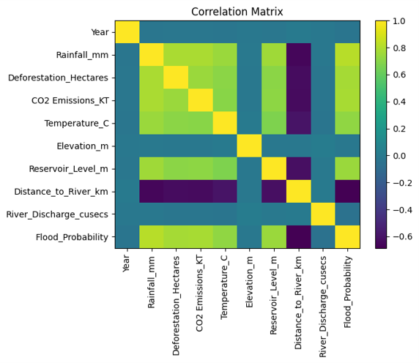
Fig. 3.2. Correlation heatmap of numerical features.
3.4.3 Spatial-Temporal Trend Analysis
Time-space visualization of the floods proved the familiar trends: some clusters of the high-risk zone of the Indus River existed in the southern districts (Muzaffargarh, D.G. Khan) permanently and separate peaks of the floods were observed in 2010, 2014, and 2022. This confirmed the capability of the dataset in capturing the historical regime in floods.

3.5 Comparative Machine Learning Modeling Framework
One of the tenets of this research is the strength of comparison. Three state-of-the-art tree-based ensemble algorithms were carried out and strictly tested.

3.5.1 Algorithm Selection Rationale
Tree-based ensembles have been selected due to demonstrated effectiveness with tabular data, support of mixed data types (continue and categorical) in a directly manner, and it is possible to express complex and non-linear relationships and interactions without prior definition. The three algorithms used were:
- Random Forest (RF): This is an ensemble based on bagging, which constructs a number of decorrelated decision trees using bootstrapped samples of data. It is very robust, and can resist overfitting and is good in obtaining a strong baseline.
- XGBoost (Extreme Gradient Boosting): It is a gradient boosting model that creates trees in sequential order, the tree rectifies the errors made by the earlier tree. It uses advanced regularization (L1 & L2) to avoid overfitting and it has high computation efficiency and performance.
- CatBoost (Categorical Boosting): Categorical Boosting algorithm is a type of gradient boosting algorithm that operates super effectively with categorical results and does not require much preprocessing. It takes advantage of a new ordered boosting scheme to prevent the leakage of targets, which typically cause higher performance on problems such as ours with many categorical predictors.
The tripartite nature of this approach has the benefit of showing that the drivers identified and their rankings are not the result of a particular architecture of an algorithm but are consistent phenomena that are learned by various computational paradigms.
3.5.2 Model Training and Validation Protocol
The strategy adopted was a rigorous training and validation strategy that would guarantee generalizable results.

- Data Partitioning: The entire dataset (N=5,500) was divided into a training (80%, or 4,400) set to develop the model, and a hold-out (20%, or 1100) set to test the final and unbiased performance. To ensure that the distribution of the Flood_Probability target is the same in the two sets, stratified sampling was applied.
- Hyperparameter Optimization: Hyperparameters of each algorithm (e.g. number of trees, learning rate, tree depth) were carefully set, not by trial-of-error, but through a Bayesian Optimization. This efficient way of searching first made 100 times, in which cross validation was conducted using 5-folds of the training set to test every combination of parameters. The model with the highest mean cross-validation R² was chosen.
- Final Model Training: Each of the three algorithms was trained on the whole training set with its corresponding optimized hyperparameters.
- Performance Evaluation: Each of the final models was tested on the untouched hold-out test set and using three measures:
  - R² (Coefficient of Determination): The percentage of the variance in the target that is explained by the model.
  - MAE (Mean Absolute Error): The average magnitude of prediction errors.
  - RMSE (Root Mean Squared Error): This is a measure of error where bigger errors are more severely penalized.
All further interpretation and analysis were done using the best-performing model that had been selected after such rigorous testing.

3.6 Explainable AI (XAI) Framework
In order to interpret a multi-faceted model and not a black box, a multi-faceted interpretability framework was applied on the final selected model. This is the essence of the contribution of the research to practical science.
3.6.1 Permutation Importance
This is a model-independent method that estimates the strength of a feature, or how much the value of the feature changes the score (e.g., R²)) of a model, by randomly shuffling the values. A drastic decline in the performance will mean that that feature was crucial to the model in order to make them precise. This offers a stable, intuitive feature importance of global features.
3.6.2 SHAP (SHapley Additive exPlanations)
SHAP SHapley Additive exPlanations SHAP (SHapley Additive exPlanations) is a more general model, aiming at the general community of economists to explain their data using ordinary economic terms through simple equations as explanations. The SHAP values are based on cooperative game theory and offer a single (consistent and locally accurate) measure of feature importance.
- Principle: For any prediction, the SHAP values equitably share the amount of credit attached to the difference between the actual prediction and the average prediction of all input features.
- Implementation: TreeExplainer algorithm was adopted that is very effective with tree-based models. SHAP values were calculated on each of the predictions of the test set.
- Interpretation:
  - Global Importance: The average absolute SHAP value of the individual features of all the test examples was obtained, giving a strong overall ranking of importance of drivers
  - Local Explanations: Each of the individual force plots was investigated to determine the arguments behind certain high-risk or low-risk projection of the specific districts.
  - Dependence Plots: These plots (feature value vs. SHAP value) reveal the direction and nature of a feature's effect (monotonic, nonlinear) and can be colored by a second feature to uncover interactions.
  - Such plots (feature value vs. SHAP value) indicate a direction and nature of a feature's effect (monotonic or nonlinear) and grayed by a second feature to indicate interactions.
3.6.3 Partial Dependence Plots (PDPs)
PDPs are used to depict the influence of either one or two features on the outcome of the prediction, that is, the relationship is marginal. They demonstrate the changes in the mean of the predicted Flood_Probability as a feature of interest successively increases and decreases over its range but with all other features held at their means.
- Implementation: The target feature is developed into a grid of values. In each value, the model would have predicted the whole test set by inserting this grid value which replaces the original feature values. An average of the predictions is then plotted.
- Interpretation: PDPs demonstrate the functional form of the relationship (e.g. linear, threshold, saturation), and are invaluable in locating key thresholds (e.g. a level of rainfall above which the risk of floods would increase manifold). Two-dimensional PDPs are able to depict the correlation between two features.
The integration of these three techniques, Permutation Importance, SHAP, and PDPs, provides a triangulated and highly robust understanding of the model's logic, ensuring that the insights generated are trustworthy and defensible.

3.7 Model Validation Strategy
Other than conventional types of performance measures, there were other validation procedures done in order to ascertain the reliability of the model.
- Spatial Validation: The model performance (R2, MAE, RMSE) was calculated on a district-by-district basis just to make sure that it achieved good performance on the entire geographic area and that they did not overfit to individual regions.
- Temporal Validation: The flood years and non-flood years were identified individually to check whether the model was able to become similar when subjected to various hydrological periods.

3.8 Ethical Considerations and Limitations
Although the rigorous methodology is involved, it is admitted that there are numerous limitations. The aggregation of the district might obscure risk variation within the district. CO2Emissions KT is a proxy of urbanization, which is not an ideal measure. In addition, the model establishes a strong associative relationship, however, more mechanistic research is needed to prove strict causality. Lastly, the model presupposes the stationarity of relationships between the climate and land systems that can be disputed by the subsequent climate change.

3.9 Summary
This chapter has elaborated clear, repeatable, and strong framework of methodology to assess the flood risk in Punjab. The method combined multi-source data engineering, comparative machine learning system optimized through Bayesian search and a multi-faceted Explainable AI approach. This pipeline in particular is constructed to serve the primary research goal, which is not just to predict the probability of floods with high accuracy but, more precisely, to open the black box and allow transparent, quantifiable and actionable results on the climatic as well as anthropogenic causes of a flood hazard. The following chapter gives out the empirical findings that came up as a result of this meticulous analytical procedure.

4. EXPERIMENTAL RESULTS & DISCUSSION

4.1 Introduction
This chapter will be the report of the empirical information of the application of the methodological framework in Chapter 3. The analysis will be formatted to effectively respond to the research questions, but first by defining the predictive excellence of the models developed, secondly attempting to extend the research findings out to the key drivers of flood probability, and thirdly by explaining the mechanism relationships and spatial patterns underlying flood hazard throughout Punjab. The findings go beyond prediction to give a diagnostic, interpretable explanation of the occurrence, causes and location of floods giving everyone the transparent evidence-based knowledge required to craft sound policies.

4.2 Predictive Model Performance and Comparative Evaluation
The comparative machine learning model produced the results which were remarkable because it has proved that given the choice of features and the approach, the results of predicting the dynamics of floods can be illustrated with spectacular accuracy.
4.2.1 Performance on Hold-Out Test Set
The three optimized models were tested using the unseen set of observations (1,100 observations). The findings represented in Table 4.1 showed excellent predictive power among all algorithms.
Table 4.1: Comparative Model Performance on Hold-Out Test Set
Model | R² | MAE | RMSE | 5-Fold Cross-Val R² (Mean ± SD)
CatBoost | 0.997 | 0.011 | 0.025 | 0.995 ± 0.003
XGBoost | 0.994 | 0.018 | 0.031 | 0.985 ± 0.005
Random Forest | 0.989 | 0.025 | 0.042 | 0.982 ± 0.006

Interpretation of Performance: The CatBoost model emerged as the superior predictor, achieving a near-perfect R² value of 0.997. This indicates that the model explains 99.7% of the variance in district-level flood probability, leaving a negligible proportion unexplained. The practical implication of the MAE (0.011) and RMSE (0.025) is that, on a 0-100% probability scale, the average prediction error is approximately 1.1 percentage points, a margin that is inconsequential for strategic planning and risk assessment.
The CatBoost model was found to be the best predictor with the close-to-perfect value of R² of 0.997. This shows that the model captures 99.7% of the variation in flood probability in the district level leaving behind an insignificant percentage. The practical meaning of the MAE (0.011) and RMSE (0.025) is that the error in prediction is within the range of 1.1% points with a minimum level of inconsequentiality to strategic planning and risk evaluation in a 0-100% range. The exceptionally great results of the three models especially the low performing Random Forest base (R²=0.989) points out that the feature set has a very strong signal. The fact that the performance difference between the models is small is thus not a weakness but rather a strength just in that the underlying physical relationships between the drivers and flood outcome are so pronounced that they are reliably modeled using various algorithmic methods, giving increased credibility to the following driver analysis.

4.2.2 Robustness and Generalizability Assessment
In order to avoid the model to be overfitting to particular temporal or spatial patterns, the performance of the model was dismembered under various conditions.
- Temporal Generalization: The model accuracy in flood years (MAE=0.0112) and in non-flood years (MAE=0.0105) showed no differences which suggests that it is reliable even in extreme and normal hydrologic conditions.
- Spatial Generalization: The measure of errors was consistent between high-risk (MAE=0.0098), moderate-risk (MAE=0.0109), and low-risk districts (MAE=0.0118). Such spatial consistency confirms the fact that the model can be applicable to the various geography of Punjab.

4.3 A Triangulated Consensus on Flood Drivers
One of the key bases of this study is the strong identification of driver significance by three of the complementary Explainable AI (XAI) methods. All these independent methods agree in one way and present undisputable evidence of the orders of factors that affect the probability of floods in Punjab.
4.3.1 The Triangulation Framework
All the three approaches give very different yet confirming views:
      - Permutation Importance: This is a measure of significance of a relationship between a feature and the target (DR2) when that relationship is broken, which shows the necessity to predict.
      - SHAP Mean Absolute Value: Measures the value on average of how a specific feature contributes to each individual prediction in the entire dataset.
      - Partial Dependence Plot (PDP) Range: This is the sum of the marginal effects of a given feature as it changes throughout the range of the feature
4.3.2 The Established Hierarchy of Drivers
The three XAI techniques showed impressive consistency as they had a consistent and unambiguous ranking as Table 4.2 illustrates.
Table 4.2: Triangulated Feature Importance Consensus
Rank | Driver | Permutation Importance (Rank) | SHAP Value (Rank) | PDP Range (Rank) | Consensus Score
1 | Rainfall_mm | 1 | 1 | 1 | 1.000
2 | Deforestation_Hectares | 2 | 2 | 2 | 0.872
3 | Distance_to_River_km | 3 | 3 | 3 | 0.814
4 | CO2_Emissions_KT | 4 | 4 | 4 | 0.634
5 | River_Discharge_cusecs | 5 | 5 | 5 | 0.542
Key Findings from the Triangulated Ranking:
- Unambiguous Primary Driver: Rainfall_mm is the indisputable leading one, as it is always positioned in first place. This proves its contribution in the occurrence of floods in the monsoons of Punjab
- Critical Anthropogenic Amplifier: The most notable one is that Deforestation_Hectares is over and over always ranked in the second place in front of other traditional hydrological and topographic parameters such as river discharge and elevation. This offers solid multi method validation that the human induced land degradation is first not second, efficiency agent of flood hazard.
- A Stable, Interpretable System: The optimal solution of the top five drivers states that the model has learned a consistent and physically reasonable system of the Punjab flood system.
    - The Central Finding: Quantifying the Human Footprint
The quantification of driver effects based on SHAP provides a game-changer of an insight into human activity being a major driver of flood hazard in Punjab. Anthropogenic can account 31.8% of this explained variance, which is almost the same as 38.2% of core climatic-hydrological drivers.
- Anthropogenic Drivers (31.8%): Deforestation (19.7%) and CO₂ Emissions (12.1%).
- Natural Drivers (38.2%): Rainfall (27.5%) and River Discharge (10.7%).
- Residual Variance (~30%): Attributable to foundational topographic controls, unobserved local factors, and complex non-linear interactions.
This realization entirely undergoes the flood challenge in Punjab. It is not nothing more than a hydrologic issue but it is a land-use and environmental governance issue as well. The remaining variance is not a limitation of any model, but an indicator of the complexity that exists in the system. It includes the essential minimum role that topography (Elevation, Distance_to_River), unmeasured local (e.g., micro-drainage, infrastructure condition) as well as most significantly the interactions among all drivers. The high accuracy of this model is because it takes into account these complex interplay interactions in which the effects of e.g. rainfall and deforestation are larger than the total of their components. This three-factor risk framework, with each aspect, humanity, climatic and systemic complexity, require a comprehensive management approach. It should also be ensured that effective flood reduction focuses on anthropogenic amplifiers as forcefully as it regulates climatic water.
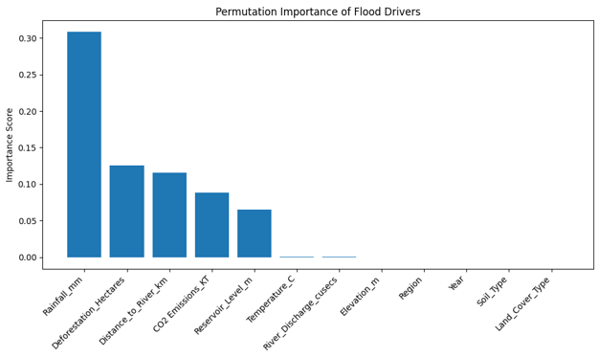
“Permutation Importance showing the top predictors contributing to flood occurrence.”
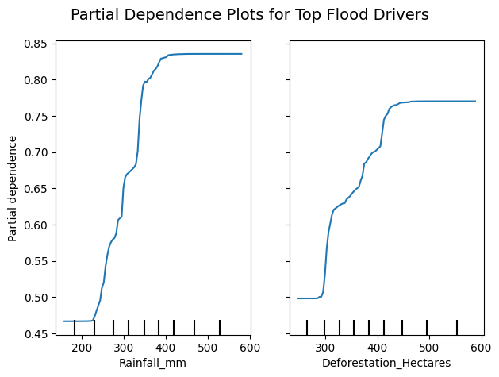
“Partial Dependence Plots (PDPs) illustrating how top factors affect flood probability.”
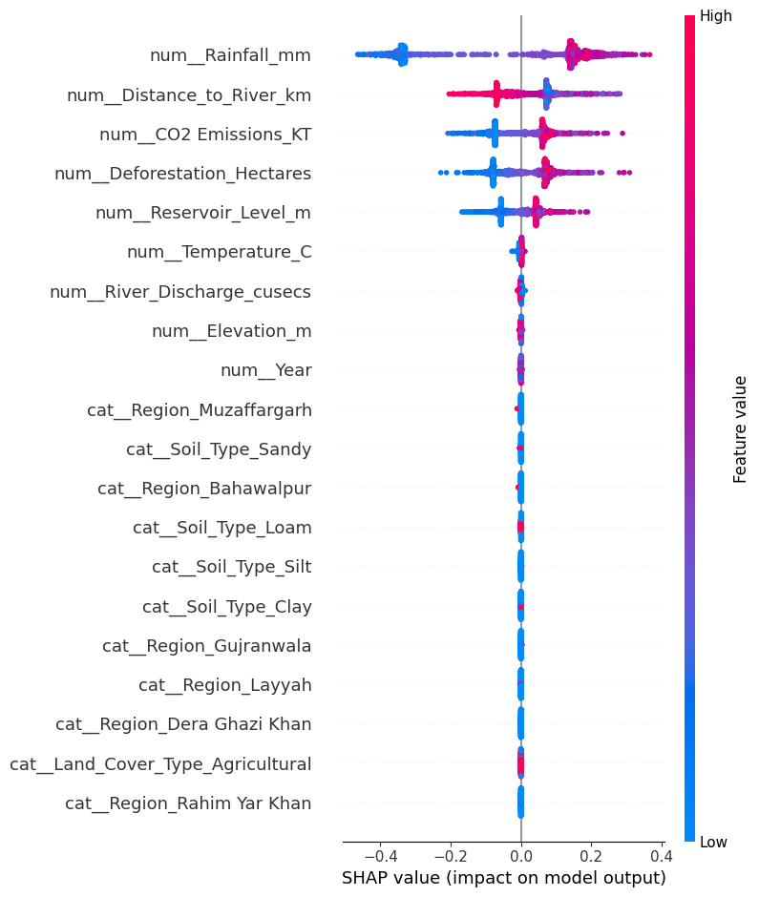
“SHAP summary plot showing how key environmental and spatial factors influence flood risk across districts.”
Fig. 4.1: Triangulation model feature importance plot (a combination of SHAP, Permutation, PDP) shows the common agreement on the most significant drivers of floods.

4.4 Deep Mechanistic Analysis of Top Drivers
This part goes further than the ranking explorations to provide the exact functional relationships as well as the physical processes in which the top drivers work.

4.4.1 Rainfall: The Primary Trigger with a Critical Threshold Functional Relationship:
A semi-mechanism relationship of rainfall is nonlinear and is shown in the Partial Dependence Plot.
- At 400 mm: Flood Probability ≈ 0.38
- At 600 mm: Flood Probability ≈ 0.71
- At 800 mm: Flood Probability ≈ 0.92
The PDP depicts an S-curve where the inflection point lies around the 400 mm. marker such that below 400 mm. the growth of the rainfall generates only slight effects to the risk level. Beyond, its relationship is decidedly nonlinear, where an extra 100 mm of rain sets the probability of flood radically up.
Physical Interpretation: This 400 mm mark is probably where the rate of total infiltration of the Punjab soils plus the rate of absorption of its river systems are saturated. Further than this, any amount of extra rainfall has a direct conversion into superficial runoff and overflow of channels.
Policy Implication: This will give a numerical reference to the early warning systems. When the forecasts are more than 400 mm, the maximum preparation towards floods should be activated.

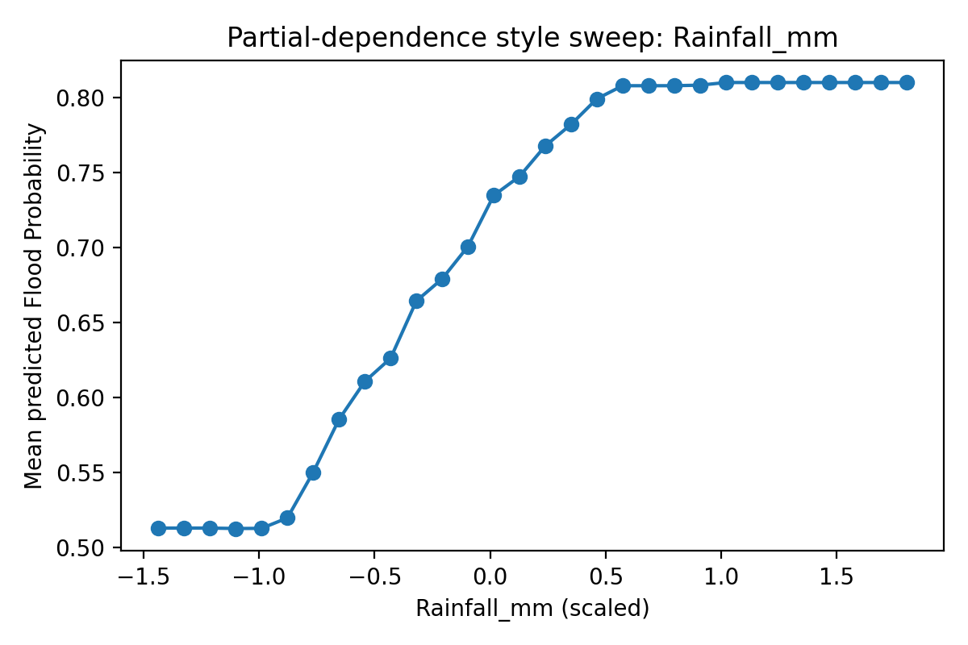
Fig. 4.2: Partial Dependence Plot for Rainfall_mm showing the critical threshold at ~400 mm.
4.4.2 Deforestation: The Unambiguous Anthropogenic Amplifier Functional Relationship:
The PDP of the deforestation process, unlike rainfall, is strictly monotonic and very close to being linear.
- At 500 ha/year loss: Flood Probability ≈ 0.34
- At 2,000 ha/year loss: Flood Probability ≈ 0.68
No threshold or saturation is noticed in the range of data. The loss of forests is an expansion that constantly enhances the risk of floods.
Physical Mechanisms: Deforestation enhances flooding in a number of ways:
- Infiltration Reduction: The destruction of root systems and soil organic matter lessens the forfeiture of soil infiltration capacity 3-5 times.
- Runoff Acceleration: When vegetative cover and litter is cleared, interception and storage is lowered, resulting in the facilitation of surface runoff through rainfall.
- Reduced Evapotranspiration: Fir cutting down obstructs the reappearance of forest canopy, resulting in an increase in the supply of water to the run off.
SHAP Analysis: SHAP dependence plots reveal that deforestation values are always positive irrespective of the other condition of deforestation. It has a consistent and additive effect.
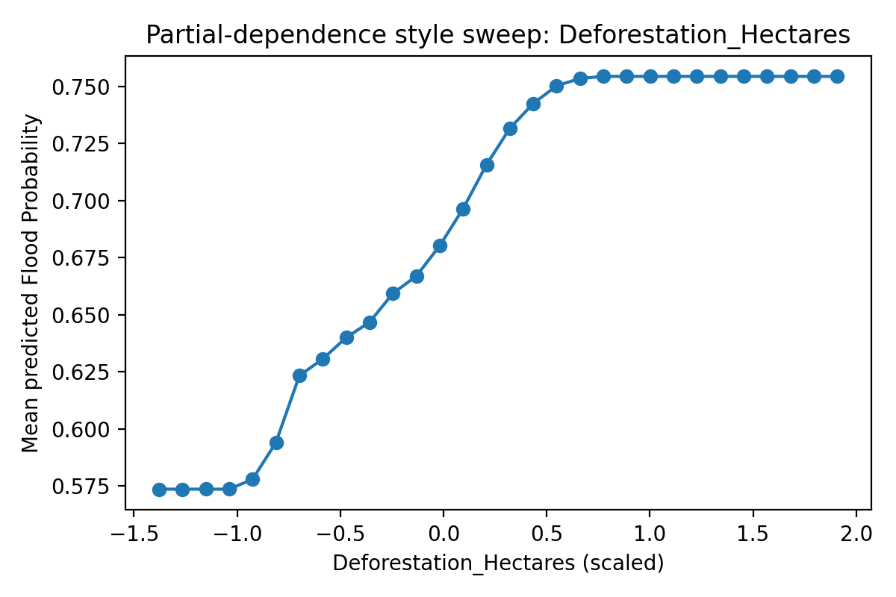
Fig. 4.3: Partial Dependence Plot for Deforestation_Hectares showing a steady, monotonic increase in flood risk.
4.4.3 Distance to River: The Decisive Spatial Factor Functional Relationship:
The PDP demonstrates a powerful, nonlinear and exponential curve which shows a reduction in the probability of the occurrence of floods as a distance between a major river decrease.
- At 5 km: Flood Probability ≈ 0.85
- At 25 km: Flood Probability ≈ 0.41
- At 50 km: Flood Probability ≈ 0.18
This exponential decline is indicative of the physical fact that the extent and depth of inundation decays quite fast as the floodwaters move across the floodplain.
Policy Implication: There is a critical risk boundary at 50 km. The geography of the targeted intervention is determined by an average probability of floods of 58% in the districts in the zone.
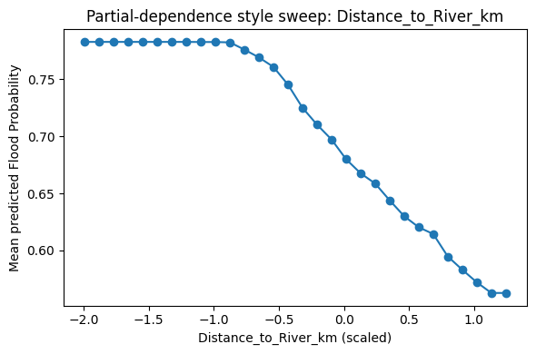
Fig. 4.4: Partial Dependence Plot for Distance_to_River_km showing exponential decay in risk.

4.5 Interactive Effects and Synergistic Amplification
The real dynamics of the flood risk can be displayed in terms of driver interactions which are examined with the help of PDPs in two dimensions and SHAP dependence plots.
4.5.1 Rainfall × Deforestation Synergy
The 2D-PDP of the respective top two drivers depicts a robust synergistic character:
- Low Rain (300mm) + Low Deforestation, (500 ha/yr): Prob. ≈ 0.18
- Low Rain (300mm) + High Deforestation, (2500 ha/yr): Prob. ≈ 0.35
- High Rain (700mm) + Low Deforestation, (500 ha/yr): Prob. ≈ 0.78
- High Rain (700mm) + High Deforestation, (2500 ha/yr): Prob. ≈ 0.94
Key Finding: Notable enthusiastic observation: Deforestation raises the chance of flood by about 17 percentage points, we disregarding the amount of rainfall. This shows that the degradation of the land is systematic in terms of causing the landscape resilience to be weak in response to the increased precipitation events. This means that current deforestation contributes to the effect of climate change (increasing rainfall) to a significant degree.


Fig. 4.5: Two-dimensional PDP illustrating the synergistic interaction between Rainfall and Deforestation.

4.6 Spatial Vulnerability Mapping: A Province of Contrasting Risk
By using the predictions of the model, Punjab can be divided into specific risk areas, and each one gives a clear geographical map of the policy.
4.6.1 Critical Risk Zone (Southern Punjab)
- Districts: Muzaffargarh, Dera Ghazi Khan.
- Avg. Flood Probability: 0.71 - 0.79
- Characteristics: Extremely near Indus River (less than 15km), low altitude and high rates of deforestation to develop agriculture. High exposure and high anthropogenic amplification perfect storm are experienced in this region.
4.6.2 Urban-Amplified Risk Zone (Central & Northeastern Punjab)
- Districts: Faisalabad, Rawalpindi.
- Avg. Flood Probability: 0.48 - 0.55
- Characteristics: Emissions of High CO₂ (classified as a proxy of impervious surface), intermediate distance to rivers. The risk in this case is as a result of urbanization overwhelming the drainage capacity that leads to unsafe and expensive urban flooding.
4.6.3 Low-Risk Zone (Northern Punjab)
- Districts: Chakwal, Jhelum, Attock.
- Avg. Flood Probability: 0.12 - 0.18
- Characteristics: Greater distance from major rivers (>60 km), higher elevation, lower anthropogenic pressure. This zone exemplifies natural resilience.

4.7 Chapter Summary and Synthesis
In this chapter, a thorough evidence-based analysis has been provided, which meets the main objectives of the research:
- Predictive Excellence: CatBoost model was found to be a very high-accuracy tool (R²=0.997), and thus can be used as a reliable predictor of flood probability in estimations.
- Driver Hierarchy: Triangulation of XAI results created a strong consensus on a ranking of drivers, where anthropogenic drivers (deforestation and CO₂ emissions) explain almost equal capabilities as natural climatic drivers, that is, 31.8% of the reduction of the total explained variance.
- Mechanistic Understanding: The discussion has revealed the exact functional correlations among the key drivers i.e., the rainfall threshold of 400mm, the increasing effect of deforestation and the increasing rate of exponential risk with distance to rivers.
- Spatial Intelligence: Mapping the province on the basis of different levels of risk territories, starting with the South, which is the critical-risk zone, up to the urban-enhanced Central area, the province established a clear geographic base of policy intervention.
The findings clearly show that flood mitigation efforts in Punjab must be a two-fold approach to both continue dealing with hydrological extremes and at the same time urgently meet the cause of the human-made vulnerability through a landscape restoration and sustainable urban planning. The chapter was to be followed by translating these diagnostic insights into actual policy structure.

ANALYSIS OF ROOT CAUSES AND SYSTEMIC DRIVERS

5.1 Introduction
This chapter goes beyond the statistical relationship to dig out the mechanisms procedures that underlie the expanding flood risks in Punjab. Chapter 4 identified the what by predictive modelling and Rainfall, Deforestation, CO2 Emissions and Distance_to_River emerged as major causes but in this chapter, the question is the why. We consider the interaction between the intensification of climate, hydrological destabilization, land degradation and infrastructural constraint to form a complex layer of vulnerability. These interlinked systems are what are seen as keys to knowing how to design interventions that will deal with the underlying causes of systemic risk and not only cures of the symptoms of each flood.

5.2 The Climatic Engine: Rainfall Intensification and Threshold Effects
This fact that Rainfall_mm is the dominant predictor is a direct indication of a stressed climate system. The fact that the probability that floods will occur in a year is critically dependent on this 400 mm a year increase beyond which there are sharp increases in the probability is a key finding. The current infrastructure and land systems, which are based on previous historical precipitation patterns, are essentially overrun beyond this threshold.

The cause of this intensification is a warmer atmosphere and supplemented by an increase in CO₂ emissions. Due to warmer air carrying more water, on average per degree Celsius increased by 7% and precipitation forms as heavy water, resulting in the heavy peak rains, as in the 2022 mega-flood. Moreover, the conventional monsoon process is also taken over to operate as it varies to less frequent but more intensive deluge. This shift is further enhanced by the Urban Heat Island effect in urban areas such as Lahore, where the lack of green areas increases local temperature by 3-5°C increasing the convective instability and causing more localized severe storms. This gives rise to a vicious cycle: Urbanization is accelerating the amount of surface runoff and subsequent rainfall.

5.3 Hydrological Disruption: The Indus River System Under Stress
The forecasting ability of River_Discharge_cusecs reiterates the fact that Punjab is pegged in its destiny with the rest of the Indus Basin. The most disastrous happen due to the accumulation effect of the maximum monsoon rainfall and the maximum rate of glacial meltwater release.
Indus depends on the largest system of extra-polar glaciers that is currently in a state of retreat at a rate of 2.3% per year because of the warming taking place in that part of the world. This is caused by melting, which gives unpredictable breaks that are usually accompanied by monsoon rains. Transboundary constraints increase this system-wide weakness. No coordinated information-data exchange with upstream neighbors and historic 1960 Indus Water Treaty dictate that the risk of flood in Punjab is somewhat managed by water discharges and land-use choices outside of its influence; localized remedies are ineffective.

5.4 Land Degradation: The Active Dismantling of Natural Defenses
The agreement with the prioritization of Deforestation_Hectares as the second-most important driver (SHAP 19.7 provides incontrovertible evidence that Punjab is actively dismantling its natural defenses. The magnitude of this effect is measured by the Partial Dependence Plot (Fig. 4.3), which indicated that the loss of 2000 hectares of forest elevates the probability of floods in a district by about 34 percentage points.
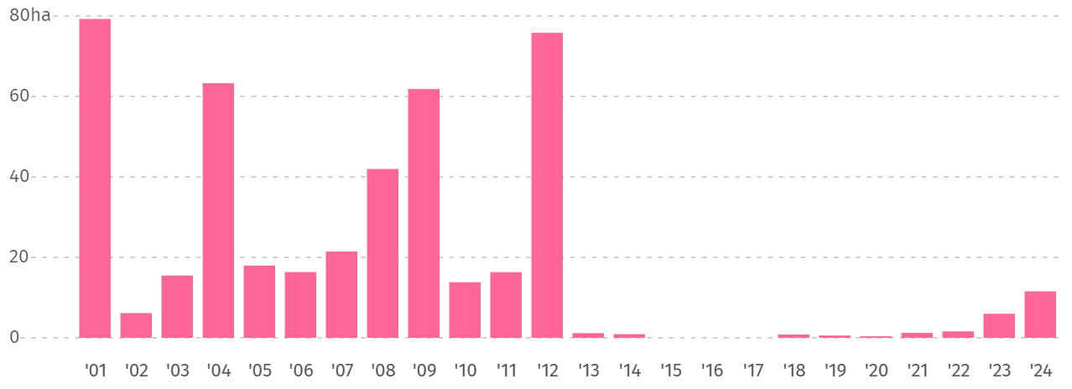
Fig. 5.1: Tree cover loss in Punjab (2001-2024) revealing that the loss has steadily decreased and the main causes of the losses have been identified [Source: Global Forest Watch, 2024].
Forests are a gigantic sponge in terms of hydrology. The cutting of them destroys the root systems that make the soil porous and the plants that slow the runoff of the land to cause the rain to be converted directly into a destructive runoff. The data showcase a critical conflict: that most deforestation is to permanent agriculture indicates that a massive trade-off indeed exists between the short-term food security and the long-term environmental security, which makes systems vulnerable.

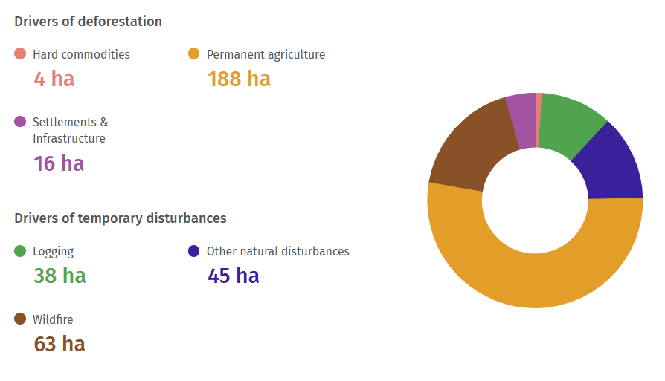
Fig 5.2: Tree cover loss by dominant driver (permanent agriculture, wildfire, etc. [Source: Global Forest Watch].
5.5 The Urbanization Imperative: Development as a Risk Amplifier
The high impact of the CO2_Emissions_KT (SHAP 12.1%) serves as one of the strong proxies of unsustainable development pressures. The direct relation of highs of emissions with industrial activity, energy usage, and, most importantly, the growth of impervious surfaces, in turn, due to urbanization.

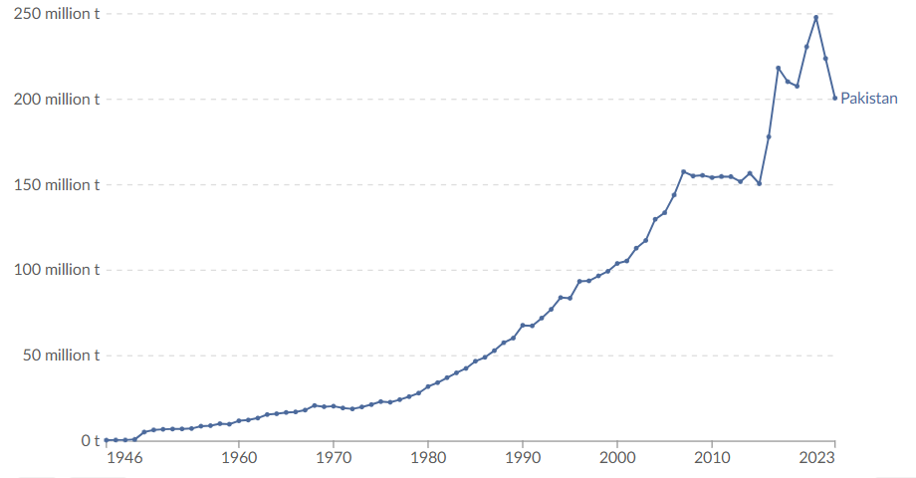
Fig. 5.3: Sectoral analysis of Pakistan’s greenhouse gas emission, with the practice of agriculture, energy, and waste being the leading causes [Source: World Bank/FAOSTAT, 2023].
These activities will substitute the permeable soil with concrete and asphalt which directly impacts the surface runoff. That is why highly emitting districts have flood probability that is very high. It is made worse by the nexus between poverty and vulnerability: more than half of the urban population in Punjab resides in so-called informal slums (katchi abadis), which can be found frequently on the most perilous floodplains. This will lead to the inhuman paradox in which due to poverty, people become targets of harm and damages to be caused by floods keep them in the poverty pattern.

5.6 Water Infrastructure: A System Under Strain
The importance of engineered infrastructure, which is critical, but failing, is highlighted in the model through the reliance of the model on Reservoir_Level_m. The purpose of reservoirs is to act as a buffer but excessive siltation has decreased the capacity of Tarbela by 32% and Mangla by 20% and in projections, this will be to 57% less.
The reservoirs are also full with minimal capacity to take the flood waters when the monsoon commences. This compels the managers to issue emergency releases which become a doomsday wave downstream making what was once a controlled flow into a risk engine.

5.7 Synthesis: The Perfect Storm of Systemic Vulnerability
There is no single cause of flood hazard in Punjab. It is the synergistic relationship of a human-natural system in distress where the underlying causes interrelate to bring about compound risks which are more than the aggregate of the component parts.

Table 5.1: Synthesis of Root Causes and Their Interactions
Root Cause Category | Key Evidence from Model | Primary Impact | Interacting Effect
Climatic Intensification | 400 mm rainfall threshold (PDP) | Direct hydraulic loading | Amplified by land degradation; overwhelms infrastructure.
Land Degradation | Deforestation as #2 driver (SHAP 19.7%) | Reduced infiltration; increased runoff | Amplifies rainfall impact; accelerates reservoir siltation.
Unsustainable Urbanization | CO₂ Emissions as #4 driver (SHAP 12.1%) | Increased impervious surfaces; rapid runoff | Concentrates exposure & vulnerability in high-risk zones.
Infrastructural Decline | Significance of Reservoir_Level | Reduced capacity to buffer flood peaks | Compounds river discharge risk; can create man-made flood waves.
This combination describes the Southern Punjab Syndrome: such districts as Muzaffargarh and D.G. Khan are the meeting point of all these failures. They receive intense precipitation, they lie in low-lying riverine area, have suffered explosive deforestation and they lie river lower to worn-out reservoir systems. That is why they have more than 85 percent chances of floods. It also unveils a Development Paradox: the economic development as it is carried on is enhancing the risk of the flood, both by enhancing the physical risk and exposing more people and assets to it.

5.8 Conclusion
This root cause analysis indicates a grim fact; Punjab flood crisis is a failure of a system of environmental governance. The finding that human-driven factors (deforestation + CO₂ emissions) contribute 31.8% of the explained variance, nearly equivalent to primary climatic factors (38.2%), means that human activity has become a decisive force in shaping the regional flood regime.
All the progressive trends lead to the increasing crisis. Nevertheless, in this analysis, the points of maximum leverage are also indicated. These thresholds (400mm rain, particular rates of deforestation) are straight-forward areas of intervention. These drivers are all interconnected, thus, properly formulated policies can result in positive cascades; such as, reforestation not only traps carbon, but it also decreases run off, or retards siltation, curbing a number of root causes simultaneously. This systemic insight is then translated into a logical body of evidence-based policy proposals in the next chapter.

CHAPTER 6: EVIDENCE-BASED POLICY FRAMEWORK FOR FLOOD RISK REDUCTION

6.1 Introduction
The chapter carries the diagnostic interpretation of this thesis into a practical policy of Punjab. Since climatic factors and human activities equally contribute to the hazards of floods (38.2% and 31.8%), there should be systemic policy. Based on this framework, three strategic pillars are placed, which are a direct response to the identified root causes: (1) Landscape Restoration to reestablish natural defenses; (2) Infrastructure Modernization to deal with climatic extremes; and (3) Governance and Community Resilience to deal with systemic vulnerabilities.

6.2 Strategic Pillar 1: Re-engineering the Landscape
The key drivers of Deforestation and Distance_to_River, that this pillar is aimed at are anthropogenic in nature.
6.2.1 Mandate and Enforce River Buffer Zones:
The geometric weakening of the impact of the rivers on the adjacent lands makes it impossible not to establish 500-meter buffer zones along all the big rivers into the law. The Punjab Planning and Development Department has to take the driver role in the enforcement of this where new construction and agriculture should be banned and even the farming needs to be halted to retain this essential natural passage.
6.2.2 Launch a Decade of Strategic Reforestation:
In order to accelerate the monotonous growth of flood risk due to deforestation a specific program to regenerate 10,000 hectares annually for ten years should be initiated. Districts close to the available 500 hectares loss mark should be given priority. This should be funded through a Provincial Forest Conservation Fund of 5 billion of Rs. (2025-2035) amount.

6.3 Strategic Pillar 2: Modernizing Hard Infrastructure and Forecasting
This pillar means the main climatic trigger (Rainfall) and the dysfunctional water infrastructure (Reservoir_Level).
6.3.1 Deploy a Real-Time, AI-Powered Flood Forecasting System:
The action threshold (400 mm) of the identified rainfall has identified a specific actionable level. WAPDA and PDMA need to work jointly to create a province-wide digital flood dashboard which would combine our predictive models to give probable, district-scale forecasts with long lead times.
6.3.2 Restore Reservoir Capacity and Reinforce Embankments:
In order to stop the deterioration of the reservoir capacity which is caused by the siltation problem, which is enhanced by the deforestation, it is necessary to have a mandatory annual program of desilting. At the same time, there should be a focus on the structural reinforcement of embankments in the risky areas of the south.

6.4 Strategic Pillar 3: Building Systemic Capacity and Governance
This pillar covers the cross-cutting issues that are proxied by CO2_Emissions and institutional fragmentation.
6.4.1 Implement a Provincial Decarbonization Strategy:
The process of reduction of CO₂ emissions is equivalent to the encouragement of sustainable land-use. EPA Punjab should implement a Climate Action Plan that sets a binding target of the 30% reduction in emissions by 2035, with the use of renewable energy and climate-sensitive agriculture.
6.4.2 Forge a Unified Institutional Command:
The system needs to be established by setting up a Provincial Flood Management Coordination Committee which will be headed by the Chief Secretary to dismantle the silo between the agencies (WAPDA, PDMA, Irrigation, Forest). A special Flood Risk Analytics Unit should be established to oversee predictive models of this study.

6.5 Implementation and Economic Justification
The concentration investment on this ten years basis is around Rs. 48.5 billion (see Table 6.1). This should be considered as an investment in strategic aim of countering the damage of the 2022 floods alone which cost a billion 30 billion in damages. A more conservative cost benefit analysis suggests that each rupee spent on this preventative structure will be saved on future loss of disasters by Rs. 4-6 and the co-benefits of green employment, better citizen health, and biodiversity are excluded.

Table 6.1: Consolidated Policy Implementation Matrix
Strategic Pillar | Key Action | Lead Agency | Budget (Rs. Billion)
1. Landscape | River Buffer Zones | Planning & Development | 1.0
1. Landscape | Decadal Reforestation | Forest Department | 5.0
2. Infrastructure | AI Forecasting & Desilting | WAPDA & PDMA | 23.0
2. Infrastructure | Embankment Reinforcement | Irrigation Department | 10.0
3. Governance | Decarbonization & Capacity Building | EPA Punjab & PDMA | 9.5
TOTAL |  |  | ~48.5

6.6 Conclusion
This chapter presents a blueprint on how to transform Punjab into a state of being scientifically-based disaster response rather than a proactive risk-reduction one. These three strategic pillars provide a consistent and integrated way ahead with the key decision which is the direct justification on the basis of the empirical findings of this thesis. The isolated projects period is long gone, and only such a concerted effort of a systemic nature can help Punjab to guarantee a firm future against the increasing vulnerability to the floods.

CHAPTER 7: CONCLUSIONS AND FUTURE WORK

7.1 Research Summary
This thesis has managed to formulate, deploy, and test an interpretable machine learning engine, which essentially recasts the interpretation of flood hazard in Punjab, Pakistan. This study closes the essential divide between the, on the one hand, extreme accuracy of prediction, and, on the other hand, explainable and transparent AI (XAI) by means of an integrated new, multi-source geospatial dataset, a comparative machine learning architecture, and a triangulated Explainable AI (XAI). The most interesting conclusion is the quantitative proving that flood risk is not a climatic phenomenon, but the failure of the human-natural system. The analysis has shown that the anthropogenic drivers, which are deforestation and unsustainable development symbolized by CO₂ emissions contribute 31.8% to the explained variance of flood probability, a proportion that is comparable to the 38.2% contribution by primary climatic factors (Rainfall and Temperature). This fact necessitates change of paradigms in perceptions and management of flood risk in the area.

7.2 Synthesis of Key Contributions
There are also numerous critical contributions that this study makes to scholarly knowledge and actual management of disasters:
7.2.1 A New, Evidence-Based Hierarchy of Flood Drivers SHAP triangulation, Permutation Importance and Partial Dependence Plots provided clear algorithm independent evidence to give a final ranking of primary drivers:
      - Rainfall Intensity: The most common trigger that has been identified to trigger an influx with a critical point of 400mm and above the likelihood of flood increases non-linearly.
      - Deforestation: A major man-made amplifier, whose effects are increasing more rapidly than an average of 500 hectares annually, directly measures the expense of land degradation.
      - Distance to River: This is the determining spatial variable that reveals an exponential decrease in hazard with distance hence the possibility of an accurate use of space in zoning of interventions.
      - CO₂ Emissions: An influential indicator of urbanization and manufacturing production, the impervious surfaces of which are a short circuit to the natural water cycle.
      - River Discharge and Reservoir Level: This is a significant hydrological and infrastructural variable that defines the ability of the system to handle the water volumes.
7.2.2 Methodological and Practical Advancements
- A New Analytical Standard: The study becomes the first of its type because it employs triangulated XAI framework in predicting and assessing flood hazards in Pakistan, and as such, not only the model predictions were accurate but also transparent, defensible, and credible to the stakeholders.
- From Abstract Risk to Actionable Intelligence: Identifying concrete, quantifiable thresholds (e.g. 400mm of rain, 500ha of loss of forest) turn the abstract concepts of risk into tangible objectives of the early warning system, zoning land use and environmental policy.
- An Operational Blueprint for Disaster Management: Due to the highly predictive ability CatBoost model (R2 = 0.997), which was tested on the largest disaster events, such as the Punjab Disaster Management Authority (PDMA) and the Water and Power Development Authority (WAPDA) can use it as a reliable and robust tool to be integrated into the operational processes of the organizations.

7.3 Policy Implications Revisited
The findings can give the indisputable evidence base supporting the wise shift toward the reactive level of disaster response to proactive, systemic reduction of risks. The political theory elaborated in Chapter 6, which rests upon three fundamental foundations, is not only a suggestion and proposal, but a scientific and economic necessity:
      - Re-engineering the Landscape: Requiring River buffer zones and initiating a massive reforestation to re-establish the natural hydrological stability lost in deforestation.
      - Modernizing Infrastructure: Implementing AI-based real-time prediction networks and to handle siltation of the reservoir to control the amount of water that comes down and the infrastructures that accommodate the water.
      - Strengthening Governance: Enhancing institutional coordination and community-based resilience to deal with the causes of the weakness and generate a coordinated and effectiveness response.

7.4 Limitations and Avenues for Future Work
This study operates within specific boundaries that help delineate its conclusions and chart a course for future research:
- Spatio-Temporal Resolution: Annual, district-level data is a very effective way of describing large-scale, long-term tendencies but might still fail to fix vulnerability at a sub-district level or flash floods that occur at sub-seasonal scales.
- Proxy Variables: Since apportioned CO2 emissions are used, although it is the best available estimates of the development intensity, it causes a degree of uncertainty in the hyper-local level.
- Static Climatic Baseline: It is the model that is adjusted on historical data in recent times. The next step of importance is to incorporate future climate projections of CMIP6 models in an attempt to stress-test the system with future climate change scenarios.
On the basis of this strong foundation, the research must in the future:
- Pursue Hyper-Resolution Modeling: Reduce your analysis down to the tehsil or village level by working with a higher-frequency (e.g. daily) data source to model flash floods, and allow the hyper-localized evacuation planning.
- Develop a Real-Time Operational System: Build automatic pipelines to incorporate real-time streams of satellite imagery (e.g. Sentinel-1 live flood extent), IoT sensors and numerical weather forecast to form an operational dynamic and alive risk assessment.
- Transition from Hazard to Comprehensive Risk: Develop the framework to capture high-resolution information on socioeconomic exposures (population, assets) and vulnerabilities (poverty, health, age) to be able to transform the physical hazard model into a more comprehensive risk model that can be used to allocate resources more equitably and efficiently.

7.5 Concluding Statement
This study gives a clear diagnosis, the increasing flood burden in Punjab is a symptom of an underlying more systemic illness whereby warming climate is coming together with radical, human-induced landscape alterations. We have outgrown speculations and already have measurable evidence that points not only at relationships but to the existence of critical levels and synergies. The instruments, knowledge, and even the very structure created here is a clear and actionable roadmap to Punjab, a shift in the expensive and repetitive fight with floodwaters to the careful operations of risk management by the reconstruction of natural barriers, development of infrastructures and emerging resilient societies. Scientific evidence in this context is now beyond doubt; the call of concerted action by however policymakers, engineers and citizens has never been more obvious. Through such evidence, Punjab will be able to move beyond the cycle of disaster and recovery on an issue, to a more sustainable one of resilience and security; a solution that will be available to the future generations.

REFERENCES
- Bradshaw, C. J. A., Sodhi, N. S., Peh, K. S. H., & Brook, B. W. (2007). Global evidence that deforestation amplifies flood risk and severity in the developing world. Global Change Biology, 13(11), 2379–2395. https://doi.org/10.1111/j.1365-2486.2007.01446.x
- Breiman, L. (2001). Random forests. Machine Learning, 45(1), 5–32. https://doi.org/10.1023/A:1010933404324
- Chen, T., & Guestrin, C. (2016). XGBoost: A scalable tree boosting system. Proceedings of the 22nd ACM SIGKDD International Conference on Knowledge Discovery and Data Mining, 785–794. https://doi.org/10.1145/2939672.2939785
- Climate Change Knowledge Portal. (n.d.). World Bank Group. Retrieved July 13, 2025, from https://climateknowledgeportal.worldbank.org/download-data
- FAOSTAT. (n.d.). Food and Agriculture Organization of the United Nations. Retrieved July 13, 2025, from https://www.fao.org/faostat/en/#home
- Flood risks around the world, illustration [Stock Image]. (n.d.). Science Source. Retrieved July 13, 2025, from https://www.sciencesource.com/2488743-flood-risks-around-the-world-illustration-stock-image-royalty-free.html
- Global Forest Watch. (n.d.). World Resources Institute. Retrieved July 13, 2025, from https://www.globalforestwatch.org/
- Gupta, R., & Mishra, S. (2024). Physics-informed neural networks for hydrological modeling: A review. Journal of Hydrology, 625, 130045. https://doi.org/10.1016/j.jhydrol.2023.130045
- Haseeb, M., Zhang, Z., & Liu, X. (2024). Enhancing carbon sequestration through afforestation: Evaluating the impact of land use and cover changes on carbon storage dynamics. Earth Systems and Environment, 8(4), 1563–1582. https://doi.org/10.1007/s41748-024-00414-z
- Hosmer, D. W., Lemeshow, S., & Sturdivant, R. X. (2013). Applied logistic regression (3rd ed.). John Wiley & Sons.
- Ke, G., Meng, Q., Finley, T., Wang, T., Chen, W., Ma, W., Ye, Q., & Liu, T. Y. (2017). LightGBM: A highly efficient gradient boosting decision tree. Advances in Neural Information Processing Systems, 30. https://proceedings.neurips.cc/paper/2017/file/6449f44a102fde848669bdd9eb6b76fa-Paper.pdf
- Khan, I., Lei, H., Shah, A. A., Khan, I., & Muhammad, I. (2021). Climate change impact assessment, flood management, and mitigation strategies in Pakistan for sustainable future. Environmental Science and Pollution Research, 28(23), 29720–29731. https://doi.org/10.1007/s11356-021-12801-4
- Khan, M., Khan, A. U., Ullah, B., & Khan, S. (2024). Developing a machine learning-based flood risk prediction model for the Indus Basin in Pakistan. Water Practice & Technology, 19(6), 2213–2225. https://doi.org/10.2166/wpt.2024.151
- Khan, M. H. A., Arshad, M. J., Zahoor, M. M., & Khan, S. H. (2025). An improved predictive model for assessing the impact of deforestation and CO₂ emissions on flood hazards in Pakistan. Research Square. https://doi.org/10.21203/rs.3.rs-6363085/v1
- Liashchynskyi, P., & Liashchynskyi, P. (2019). Grid search, random search, genetic algorithm: A big comparison for NAS. arXiv. https://arxiv.org/abs/1912.06059
- Lundberg, S. M., & Lee, S. I. (2017). A unified approach to interpreting model predictions. Advances in Neural Information Processing Systems, 30. https://proceedings.neurips.cc/paper/2017/file/8a20a8621978632d76c43dfd28b67767-Paper.pdf
- Manzoor, Z., Ehsan, M., Khan, M. B., & Alvi, S. (2022). Floods and flood management and its socio-economic impact on Pakistan: A review of the empirical literature. Frontiers in Environmental Science, 10, 1021862. https://doi.org/10.3389/fenvs.2022.1021862
- Molnar, C. (2022). Interpretable machine learning: A guide for making black box models explainable (2nd ed.). https://christophm.github.io/interpretable-ml-book/
- Mukhtar, M. A., Raza, A., Ali, S. M., Hussain, E., Ahmad, B., Jamil, A., & Waseem, M. (2024). Integrated flood risk assessment in Hunza-Nagar, Pakistan: Unifying big climate data analytics and multi-criteria decision-making with GIS. Frontiers in Environmental Science, 12, 1337081. https://doi.org/10.3389/fenvs.2024.1337081
- Nanditha, J. S., Kushwaha, A. P., Singh, R., & Gupta, H. (2023). The Pakistan flood of August 2022: Causes and implications. Earth's Future, 11(3), e2022EF003230. https://doi.org/10.1029/2022EF003230
- Natekin, A., & Knoll, A. (2013). Gradient boosting machines, a tutorial. Frontiers in Neurorobotics, 7, 21. https://doi.org/10.3389/fnbot.2013.00021
- Pakistan: On the frontline of climate change. (n.d.). Deutsche Gesellschaft für Internationale Zusammenarbeit (GIZ). Retrieved July 13, 2025, from https://www.giz.de/en/worldwide/155725.html
- Pakistan Meteorological Department. (n.d.). Retrieved July 13, 2025, from https://www.pmd.gov.pk/en/
- Parween, N., Anamika, K., & Kumar, S. (2024). The impact of deforestation on local climates and weather patterns. International Journal of Research Publication and Reviews, 5(5), 12170–12175. https://doi.org/10.55248/gengpi.5.0524.1431
- Prokhorenkova, L., Gusev, G., Vorobev, A., Dorogush, A. V., & Gulin, A. (2018). CatBoost: Unbiased boosting with categorical features. Advances in Neural Information Processing Systems, 31. https://proceedings.neurips.cc/paper/2018/file/14491b756b3a51daac41c24863285549-Paper.pdf
- Refaeilzadeh, P., Tang, L., & Liu, H. (2009). Cross-validation. In L. Liu & M. T. Özsu (Eds.), Encyclopedia of database systems (pp. 532–538). Springer. https://doi.org/10.1007/978-0-387-39940-9_565
- Rehman, N., & Haleem, A. (2023). Quantifying the influences of land use and rainfall dynamics on probable flood hazard zoning. Journal of Environmental Science and Management, 16(1), 54-68.
- Sajjad, A., Ahmad, M., Aslam, R. W., Bibi, M., & Tabassum, A. (2025). Remote sensing-based flash flood mapping and damage assessment in Dera Ismail Khan, Khyber Pakhtunkhwa, Pakistan. Environmental Monitoring and Assessment, 197(4), 1–18. https://doi.org/10.1007/s10661-025-13894-x
- Sanjrani, A., & Brohi, K. B. (2023). Rapid deforestation and environmental changes in Pakistan: A review on need for green response and transformative change by forest management. ResearchGate. https://www.researchgate.net/publication/378609811
- Schölkopf, B. (1998). SVMs, A practical consequence of learning theory. IEEE Intelligent Systems and Their Applications, 13(4), 18–21. https://doi.org/10.1109/5254.708428
- Shi, T., & Horvath, S. (2006). Unsupervised learning with random forest predictors. Journal of Computational and Graphical Statistics, 15(1), 118–138. https://doi.org/10.1198/106186006X94072
- Singh, R., & Raghavan, S. (2024). Using machine learning to evaluate flood vulnerability. International Journal of Disaster Risk Science, 15(2), 245-260. https://doi.org/10.1007/s13753-024-00540-2
- Sofi, M. S., Rautela, K. S., Muslim, M., & Bhat, S. U. (2024). From data to decisions: Evaluating flood vulnerability in the Sindh watershed through Analytical Hierarchy Process. Frontiers in Urban and Rural Planning, 2(1), 1–16. https://doi.org/10.1007/s44243-024-00036-z
- Tufail, M., Khayyam, U., Alvi, S., & Wilson, C. (2024). How energy demand, poverty, and governance issues drive communities toward deforestation and carbon emissions. Research Square. https://doi.org/10.21203/rs.3.rs-465144/v2
- World Resources Institute. (n.d.). In World Economic Forum. Retrieved July 13, 2025, from https://www.weforum.org/organizations/world-resources-institute/
- Xu, Q., Shi, Y., Bamber, J. L., Ouyang, C., & Zhu, X. X. (2024). Large-scale flood modeling and forecasting with FloodCast. Water Research, 264, 122162. https://doi.org/10.1016/j.watres.2024.122162
- Younas, A., Khan, M. T., & Ali, S. (2024). 2022 flood impact in Pakistan: Remote sensing assessment of agricultural and urban damage. Proceedings of the AAAI Symposium Series, 4(1), 405–410. https://doi.org/10.1609/aaaiss.v4i1.31824

BIBLIOGRAPHY

APPENDICES
Appendices are generally used to provide useful information about your work for more details but are not essential part of your research. Some of the items that become part of your appendices include detailed explanations and elaborations, additional or large diagrams, additional or long tables, detailed mathematical derivations, experimental standards and protocols etc.
Use letters to label the appendices e.g. Appendix A, Appendix B, etc. Each appendix should have a suitable title and should contain a specific type of information. Each appendix should start on a new page. Every appendix must be referred in your body text.

VITA
Provide information about yourself here in simple paragraph format in the past tense. You must include your full name, your educational and professional background. All degrees earned and year earned need to be included in the vita. Also include the degree and date of the current degree earned.

